USER GUIDELINES - SHORT VERSION
ORBOF-Inn

First-time use

Download necessary software from Norges Bank

- Open Internet
- Go to Norges Bank's area
- http://www.norges-bank.no/stat/orbof/inndata/inndata_index.htm
- Type the following: Ident: nborbof
Password: fobroff
- Click on the Zip file (all the material is compressed into a ZIP file)
- Choose save
- Choose area to save the Zip file in (the computer often provides suggestions, choose a temporary area, for example temp)
- Close the window
- Use Explorer and go to the area where you saved the file.
- Double click on ORBOF-filer.exe
- Use Browse in the Zip menu and click until you get to the folder where you want to save the ORBOF system (the system creates a separate folder called ORBOF when the file is unzipped).
- Click Unzip to unzip the files.
- Click OK
- Click Close

Configure yourself as a user – see also Item 4.1 of the User Guidelines
- Open Explorer and find the area where you saved the files
- Go to the folder called System
- Click on ORBOF-Inn (it could be an advantage to put this on the desktop as a shortcut. This is done by clicking the right-hand mouse button and selecting "create shortcut" and dragging or copying the shortcut to the desktop)
- Type in the data processing centre number, registration number, name and e-mail address. Note: The name and e-mail address are only filled in to test the e-mail function.
- New functions not found in earlier versions: You must also select which e-mail system you to receive correct guidance from the system. You also choose whether the system's Internet access is to be activated. Users who in earlier versions of the program did not have problems communicating with the Internet, should therefore activate this function.

We recommend that you run through the test functions to see if the computer system has the necessary installations and programs to enable use of the software.

When Norges Bank has an updated version available, those who have activated the system's Internet access will be informed of the new version when they start the program. Answer yes when asked if the new version is to be downloaded. All reporters will also be notified by Norges Bank when we publish a new version of ORBOF-Inn. The procedure is then as follows:

Updating the system

Note: applies to users who have activated the Internet access function

- Click on the YES button. Before you click on the Zip file, ORBOF-Inn should be closed.
- Answer Yes when asked if the file is to be replaced
- Follow the procedure under the item above regarding downloading and unzipping of FiksValider.
- Remember to click on 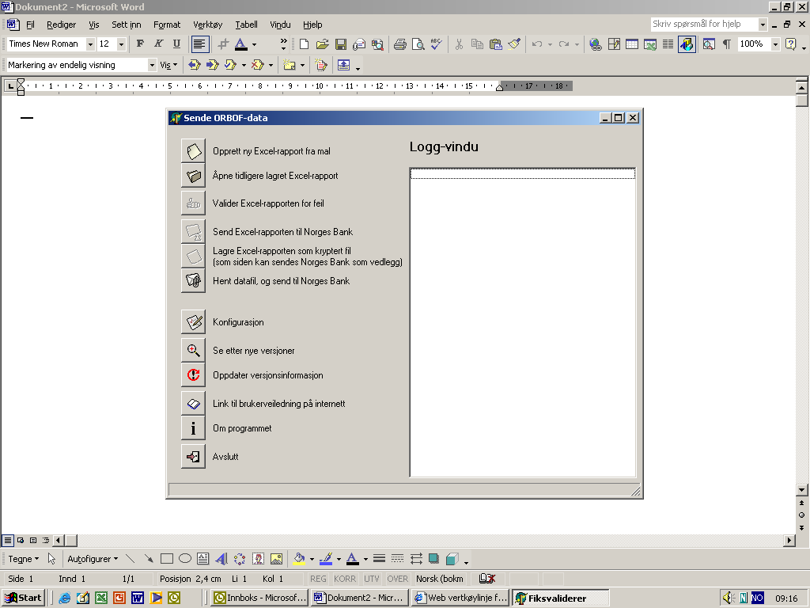 update version information after the program has been restarted.

Making and sending a new report

This is a quick guideline that can be used when a new report is to be prepared and sent to Norges Bank.
- Click on 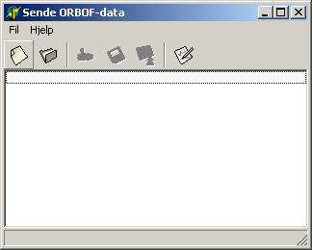 Selects new report in the menu.
- Choose report number from the pulldown menu. The last reporting period will appear automatically.
- Choose first-time submission.
- Click to where the file is to be saved (The computer will make a suggestion)
- Type the file name of the report

A "formatted" spreadsheet will appear with boxes that have been completed in advance with information the reporters have given in the configuration window.
- Click on the 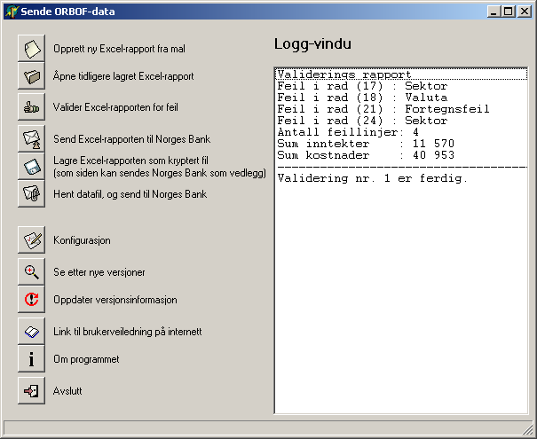 minimise button at the top right in the ORBOF-Inn menu so that the program is placed in the background.
- Use the pulldown menu in cell A12 to activate the first item in the accounts.

Column B will be completed automatically when a value is selected in A.

- Use the pulldown menu in column C to find the right sector.
- Use the pulldown menu in column D to select business.

For items where the sector and business only have one possible value, the cell will automatically be assigned this value and the cursor will skip to the next cell to be completed.

This procedure must be repeated until the accounts have been completed. However, as a rule there will be many items with the same value in columns A and C because there often are may items, particularly under the main groups 2, lending and 6 borrowings. Item 2.54.91 for example may have many sectors to be distributed by business and there will also be several businesses for each sector.

In order to streamline the registration process, the lines can be copied. This is done by copying column A downwards and then copying columns C, D and E. Copied values are changed and correct values entered. Note that the checking function related to the pulldown menus disappears when copying.

Do the following when the figures have been entered:

- Click the sort button to sort the items.
- Click 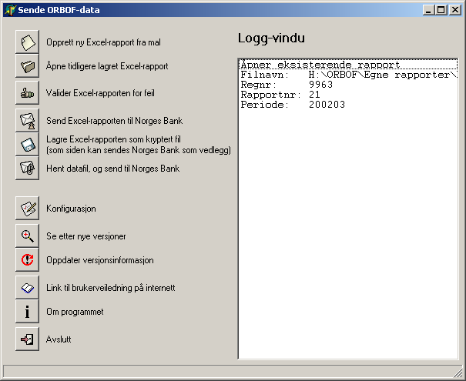 Validate the Excel report for errors.

The validation program will now review the report and errors will be marked in red in the spreadsheet, while the status of the errors will be displayed in the log window in the menu. The errors must be corrected and the validation program must be rerun.

Send the report to Norges Bank when the report is complete and the errors corrected.

- Click send the Excel report to Norges Bank.

The data will now be sent to Norges Bank and entered directly into Norges Bank's database. A status report will be sent via e-mail from Norges Bank as feedback on submitted data.

Send a correction

This is a quick guideline that can be used when a correction of previously submitted reports is to be sent.
- Click Select new report in the menu.
- Choose report number from the pulldown menu.
The last reporting period appears automatically
- Choose correction.
- Click to where the file is to be saved (The computer will make a suggestion)
- Type the file name on the report

A "formatted" spreadsheet will appear with boxes that have been completed in advance with information the reporters have given in the configuration window.
- Click on the minimise button in the top right-hand corner in the FiksValider menu so that the program is placed in the background

- Use the pulldown menu in cell A12 to activate the first item in the accounts.

Column B will be completed automatically when a value is selected in A.

- Use the pulldown menu in column C to find the right sector
- Use the pulldown menu in column D to select business.

For items where the sector and business only have one possible value, the cell will automatically be assigned this value and the cursor will skip to the next cell to be completed.

This procedure must be repeated until the corrections have been completed.

Do the following when the figures have been entered:

- Click the sort button to sort the items.
- Click Validate the Excel report for errors.

The validation program will now review the report and errors will be marked in red in the spreadsheet, while the status of the errors will be displayed in the log window in the menu. The errors must be corrected and the validation program must be rerun.

Send the report to Norges Bank when the report is complete and the errors corrected.

- Click send the Excel report to Norges Bank.

The data will now be sent to Norges Bank and entered directly into Norges Bank's database. A status report will be sent via e-mail from Norges Bank as feedback on submitted data.

Send new report using ”old spreadsheets”

- Click 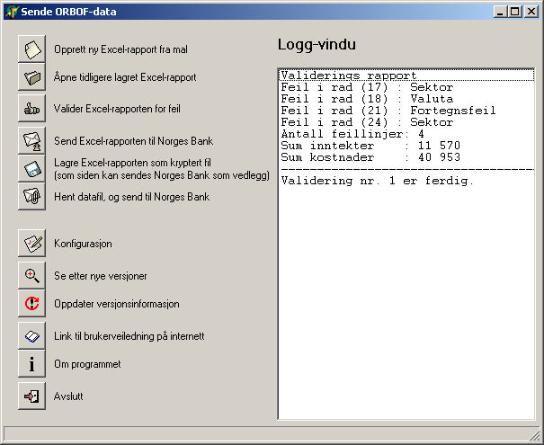 Choose Open previously saved Excel report.
- Retrieve the report to be used.
- Click on the minimise button in the top right-hand corner of the FiksValider menu so that the program is placed in the background.

- Click Validate the Excel report for errors.

The validation program will now review the report and errors will be marked in red in the spreadsheet, while the status of the errors will be displayed in the log window in the menu. The errors must be corrected and the validation program must be rerun.

Note: When old spreadsheets are used there will be many items with the value 0 or no value. Many of these will come up as errors after validation has been run. You should therefore delete these rows so that unnecessary errors do not occur.

Send the report to Norges Bank when the report is complete and the errors corrected.

Click send the Excel report to Norges Bank.

The data will now be sent to Norges Bank and entered directly into Norges Bank's database. A status report will be sent via e-mail from Norges Bank as feedback on submitted data.

Send new report using ”flat file”

Click 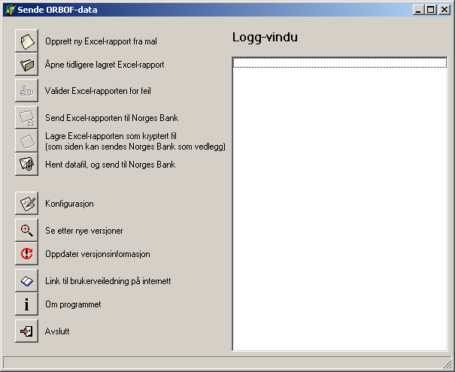 Retrieve data file and send to Norges Bank.
Retrieve the file to be used.

The data will be encrypted, sent and entered directly into Norges Bank's database. A status report will be sent via e-mail from Norges Bank as feedback on submitted data

New functions in ORBOF-Inn

Save the Excel report as an encrypted file.
Click 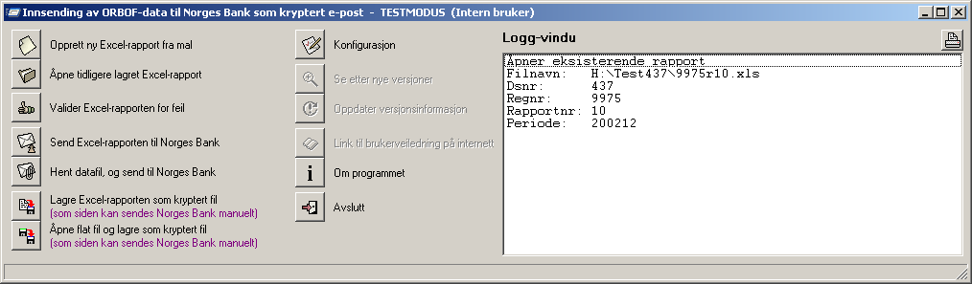 to save the Excel report as an encrypted file.

The file can then be copied and pasted into a normal e-mail that is sent to Norges Bank at the following e-mail address: STATestRapportering@norges-bank.no
This is a new function that can be used by reporters who do not want to use the normal send function in the program. This particularly applies to users who have other e-mail systems than Outlook and other Exchange products.

Open flat file and save as encrypted file
Click open flat file and save as encrypted file.

The file can then be copied and pasted into a normal e-mail that is sent to Norges Bank at the following e-mail address: STATestRapportering@norges-bank.no
This is a new function that can be used by reporters who do not want to use the normal send function in the program. This particularly applies to users who have other e-mail systems than Outlook and other Exchange products.

